`

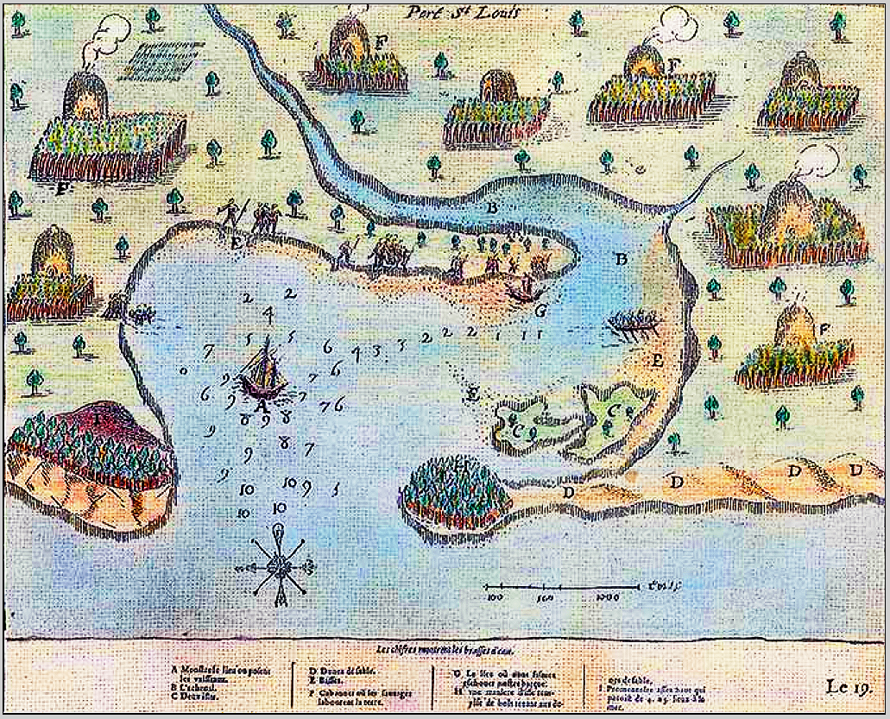

**Champlain’s Map from *Les Voyages de Sieur de Champlain Xaintongeois* [“­­­of saintly stature] (Paris, 1613)**

**This map depicts Plymouth, MA, Harbor that Champlain charted with sounding depths in fathoms along with accurate depictions of the cornfields and bark covered houses. Even depicted is a drying bed of wood planks for corn in the upper left. All these features are similar to those that were near Phillips Pond and on Indian Point Road in Marblehead bordering Salem Harbor.**

**The various basalt and granite spades that are in this shelf are those made by the Natick Language-speaking Algonquians 7,000 Years Ago (Before the Present, BP) with the inception of agriculture here.**